Technical writing Assignment
1. Learn Markdown
2. Find a technical document and write a short review (not less than 200 words).
● Identify the intended audience
● The purpose of the document
● The type of technical writing it may fall under
● Is it clear and effective? (Why / Why not)

–Learn markdown–
What is markdown? Markdown is a type of coding language that allows its user to format text using a plain-text editor, making it easy to add editing components like headers, lists, boldface, and italics to their documents.
Why use markdown? Markdown simplifies a user’s document and includes the following advantages:
Portability- markdown gives a document easy access with a variety of document editors.
Platform Independence- markdown is operable with any type of operating system
Future Proof- a user could read a Markdown-formatted text using a text editor even if the application you’re using stops working.
How is Markdown used? To use markdown requires adding simple syntax to your text to indicate formatting.
For example:
- Headers: the hash (#) symbol is entered before a space whereas the number of # symbols indicate the level of the header. # This is an H1 ## This is an H2 ###### This is an H6
- Emphasis: Use asterisks or underscores to italicize or bold text. *italic* or _italic_ **bold** or __bold__
- Lists: Use asterisks for bullet points and numbers for numbered lists. * Item 1 * Item 2 * Item 3 1. First 2. Second 3. Third
- Links: Use square brackets for the text and parentheses for the URL. [This is a link](http://example.com)

–-Find a technical document and write a short review (not less than 200 words)—
The technical document reviewed here is Technical Documentation Job Description (TDJD).
TDJD exhibited a clear documentation based on the requirements of a typical technical writing process, for its specific audience–technicians and experts. This is seen in the pre-writing stage where the author started off with the snippet of urgent need of experienced candidates–their audience, by their growing company. The author further expanded into the scope of the document by outlining the qualities and qualification expected of the company’s potential experts and technicians well-informed on the required responsibilities. At the end, the communication in technical document was very organized and effective. Therefore, the target audience are apparently, technicians and experts in technical documentation; the purpose of this document is to recruit experts for the position of technical documentation; for the type of technical writing, this document can be categorized as “process document” because it outlined a process instructing potential candidates for a technical documentation job, explaining what skill they must possess to stand a chance of getting employed; Is it clear and effective? A mere looking at the document, the information intended was evidently passed because the author carefully applied the three steps used for technical writing. The three steps a technical writer must show when preparing a technical document are as follows: preparing stage, drafting stage, and revision.
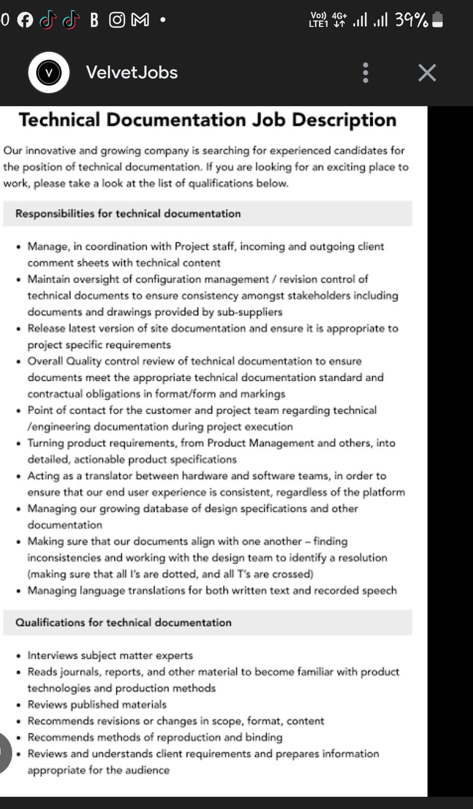
APPENDIX

